**Data Analyst and Health Data Fellow Screening Exercise**

**By Jessey Sitima**

**Exercise 1:**  **An SQL query that will display the duplicate records.**

**Query:**

SELECT *, COUNT(*) as duplicate FROM user GROUP BY first_name, last_name, gender HAVING duplicate>1;

**Explanation:**

This SQL query selects all rows from the "user" table where there are duplicates in the combination of "first_name," "last_name," and "gender." It counts these duplicates and only returns rows where the count is greater than 1.

**Solution:**

The screenshot below shows the table before and after running the query;

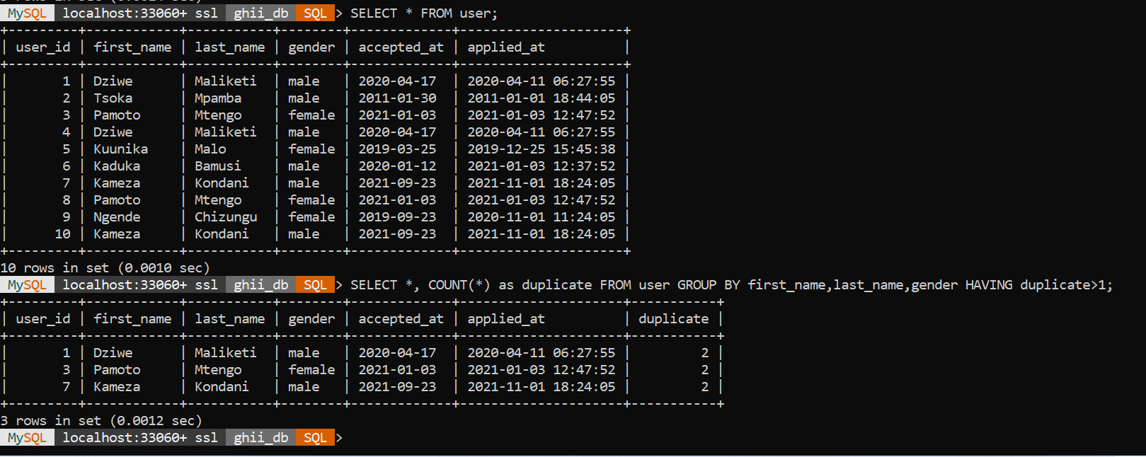

**Exercise 2:**

1. **Two ways in which the query can be restructured (optimized) to run efficiently**
2. **Use of Common Table Expression (CTE) for the Subquery:**

Instead of using a subquery within the main query's FROM clause, we can rewrite the subquery as a Common Table Expression (CTE). CTEs are often easier to read and maintain, and they sometimes result in better query optimization. Using a CTE can make the query more readable and potentially improve its performance.

1. **Indexing:**

Ensure that the relevant columns used for joining and filtering the data are properly indexed. In this case, we can add indexes to the following columns:

* Index the "person_id" column in the "Patient_Visit" table since it's used for grouping and joining.
* Index the "person_id" column in the "Diagnosis_Stage" table.
* Proper indexing can significantly improve the query's performance by reducing the time it takes to access and retrieve the required data.

**(b) Query for the solution above:**

Making the Subquery as Common Table Expression CTE:

WITH MaxVisitDates AS (

SELECT person_id, MAX(visit_date) AS visit_date

FROM Patient_Visit

GROUP BY person_id )

SELECT pd.person_id, pd.first_name, pd.last_name, mvd.visit_date

FROM Patient_Demographic pd

INNER JOIN MaxVisitDates mvd ON pd.person_id = mvd.person_id

WHERE pd.person_id IN (SELECT DISTINCT person_id FROM Diagnosis_Stage);

**Exercise 3: Data Duplication**

The below python script uses the panda library for reading data. The python script and the csv supporting docs can be found at <https://github.com/JesseySitima/GHII-Data-analyst-Exercise.git>

import pandas as pd

# task a: Read the CSV file

input_file = "client_purchases.csv"

df = pd.read_csv(input_file)

# task b: Find and identify duplicate records

duplicates = df[df.duplicated(subset=['First Name', 'Last Name', 'Email', 'Phone', 'Address', 'Zip Code', 'Gender', 'Date of Birth', 'Product', 'Quantity', 'Cost'])]

# task c: Remove the duplicate records

df = df.drop_duplicates(subset=['First Name', 'Last Name', 'Email', 'Phone', 'Address', 'Zip Code', 'Gender', 'Date of Birth', 'Product', 'Quantity', 'Cost'], keep='first')

# task d: Export the cleaned CSV file

cleaned_output_file = "client_purchases_deduplicated.csv"

df.to_csv(cleaned_output_file, index=False)

# task e: Identify unique clients and assign unique IDs

unique_clients = df[['First Name', 'Last Name', 'Email', 'Phone', 'Address', 'Zip Code', 'Gender', 'Date of Birth']].drop_duplicates().reset_index(drop=True).reset_index()

unique_clients.rename(columns={'index': 'Client ID', 'First Name': 'First Name', 'Last Name': 'Last Name', 'Email': 'Email', 'Phone': 'Phone', 'Address': 'Address', 'Zip Code': 'Zip Code', 'Gender': 'Gender', 'Date of Birth': 'Date of Birth'}, inplace=True)

# Export the unique clients to a CSV file

unique_clients_output_file = "clients_unique.csv"

unique_clients.to_csv(unique_clients_output_file, index=False)

**Exercise 4: Data Privacy and Security**

1. From the given deduplicated CVS, variables that qualify as Personal Identifiable Information are:

* First Name
* Last Name
* Email
* Phone
* Address
* Zip Code
* Gender
* Date of Birth

1. Below is a python script using the Faker library which generates realistic but fake data.

import pandas as pd

from faker import Faker

# Initialize the Faker generator

fake = Faker()

# Read the CSV file with PII

input_file = "client_purchases_deduplicated.csv"

df = pd.read_csv(input_file)

# Anonymize sensitive data

df['First Name'] = [fake.first_name() for _ in range(len(df))]

df['Last Name'] = [fake.last_name() for _ in range(len(df))]

df['Email'] = [fake.email() for _ in range(len(df))]

df['Phone'] = [fake.phone_number() for _ in range(len(df))]

df['Address'] = [fake.street_address() for _ in range(len(df))]

df['Zip Code'] = [fake.zipcode() for _ in range(len(df))]

df['Gender'] = [fake.random_element(elements=('Male', 'Female')) for _ in range(len(df))]

df['Date of Birth'] = [fake.date_of_birth(minimum_age=18, maximum_age=90).strftime('%m/%d/%Y') for _ in range(len(df))]

# Saving the anonymized data to a new CSV file

anonymized_output_file = "clients_deidentified.csv"

df.to_csv(anonymized_output_file, index=False)